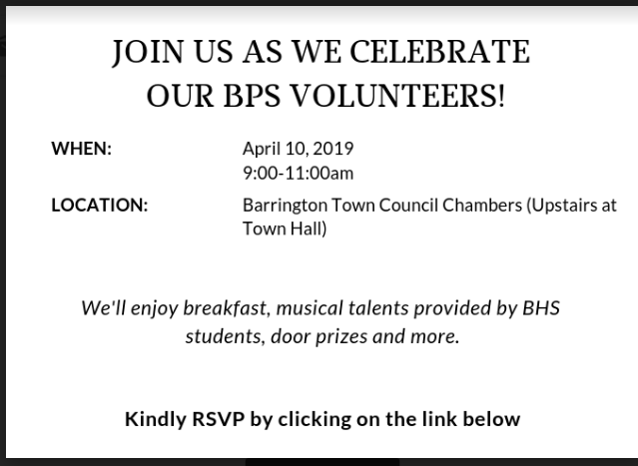
https://www.signupgenius.com/go/30e084cadad2aa2f94-bpsvolunteer2

