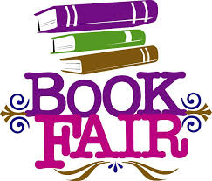

Primrose Hill Schools Annual Book Fair begins Monday December 10th during Parent Teacher Conferences and will run through Friday Dec 14th
Family Night is Thursday Dec 13th from 5-7pm

We are still looking for VOLUNTEERS to help make this year’s fair a success!
Please consider volunteering your time.
Complete list of volunteer opportunities can be found on MySchoolAnywhere.
Thank you!
Kara Estrella
(karaestrella@gmail.com)

