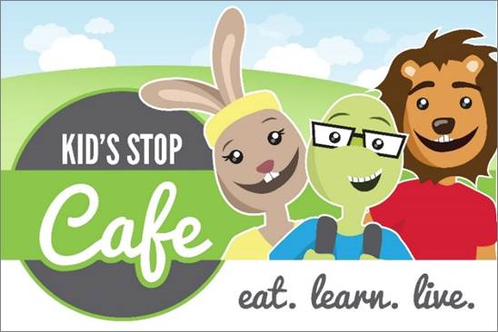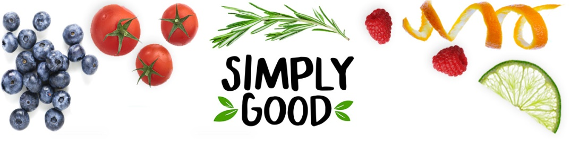

Barrington Elementary

**Student: $2.60 Reduced: 40**¢ **Adult: $3.50 Milk: 55**¢ **April Lunch Menu**

A full student lunch includes a choice of entrée supplying protein and whole grain,

two (2) vegetable side dish, two (2) fruit side dishes, and a choice of milk.

Milk choices include 1% white and skim chocolate

|  |  |  |  |  |  |  |  |  |  |  |  |  |  |
| --- | --- | --- | --- | --- | --- | --- | --- | --- | --- | --- | --- | --- | --- |
| Monday | | | **Tuesday** | | | **Wednesday** | **Thursday** | | | | | **Friday** | |
| 2  **1.** Brunch for Lunch  French Toast Sticks  Sausage Patty  **Hash Brown Potatoes**  **Carrot Raisin Salad** | | 3  **1**. Beef Taco  Lettuce and Cheese  **Salsa**  **Seasoned Corn** | | | 4  **1.** Chicken Patty Sandwich  **BBQ Baked Beans**  **Baked French Fries** | | 5  **1.** Macaroni and Cheese  Dinner Roll  **Baby Carrots**  **Green Beans** | | | | | 6  **1.** Classic Cheese Pizza  **Caesar Salad**  **Broccoli Bites** | |
| **Alternate Meals 2. Cheese Stuffed Bread Sticks with Sauce 3. Hummus and Fresh Veggie Fun Lunch (V)** | | | | | | | | | | | | | |
| 9  **1**. Cheeseburger  **Oven Baked Fries**  **Homemade Pickles** | | 10  **1**. Beef Nachos  Lettuce and Cheese  **Salsa**  **Steamed Corn** | | | | 11  **1.** Chicken Tenders  Warm Biscuit  **Steamed Carrots**  **Mashed Potato** | 12  **1.** BBQ Pulled Pork Sliders  **Baked Beans**  **Cole Slaw** | | | | 13  **1.** Classic Cheese Pizza  **Mix Greens**  **Broccoli Bites** | | |
| **Alternate Meals: 2. Chicken Nuggets offered with a slice of bread 3. Sunbutter Dunkers (2 breadsticks & veggies) (V)** | | | | | | | | | | | | | |
| http://rdontheroad.files.wordpress.com/2014/02/bch.jpg | | | | | | | | | | | | | |
|  | | | | | | | | | | | | | |
| 23  **1.** General Tso’s Chicken Steamed Brown Rice  **Steamed Broccoli**  **Carrots** | 24  **1**. Beef Taco  Lettuce and Cheese  **Salsa**  **Seasoned Corn** | | | 25  **1.** Chicken and Gravy  Dinner Roll    **Mashed Potato**  **Fresh Ratatouille** | | | | 26  **1.** Classic Cheese Pizza  **Mix Greens**  **Roasted Garbanzo Beans** | | 27  **No School** | | | |
| **Alternate Meals: 2. Mini Pancakes with Sausage Patty 3. Vegan Garden Burger on a Bun** | | | | | | | | | | | | | |
| 30  **1.** Brunch for Lunch  Whole Grain Pancakes  Sausage Patty  **Hash Brown Potatoes**  **Carrot Raisin Salad** | CHK12 EarthMonth_banner-leaderboard | | | | | | | | | | | |
| **Alternate Meals 2. Cheese Stuffed Bread Sticks with Sauce 3. Hummus and Fresh Veggie Fun Lunch (V)** | | | | | | | | | | | | | |
| **Available Daily**  **with any Meal:**  Assorted Fresh Fruit  Assorted Chilled Fruit | | C:\Users\Chartwells\Desktop\Food Focus Headers\SimplyGood_Header_GardenVeg.jpg | | | | | | | **Barringtonschools.nutrislice.com or download**  **the app for your smartphone** | | | | |

**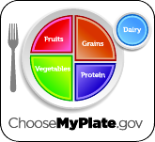**

**If you have any food allergies, please let us know!**

**Questions or Comments?**

Please call, Foodservice Director

Kim Orr at

401-253-1452

**Nutrition Guidelines make it easier than ever for students to make healthy food and beverage choices at school.**

**This institution is an equal opportunity provider and employer**